

**Business Analytics**

**Section ___**

**Name:_________________________________________Username on BB:______________________**

**Name:_________________________________________Username on BB:______________________**

**Name:_________________________________________Username on BB:______________________**

**Name:_________________________________________Username on BB:______________________**

**In Class Exercises 2**

**Instructions:** You must complete and submit these exercises by the end of the class session as a group (max 4 people). I will be available to answer your questions. The objective of these exercises is for you to take your understanding of the material a little bit further; hence, the more difficult nature for some of the questions.

1. ***For this in-class exercise, please write your answers on your Excel file and submit only one Excel file.***
2. ***Ignore any integer restrictions.***
3. ***Solve the following problems using Excel’s Solver and report the optimal solution, i.e., the optimal values of the decision variables, and the optimal objective function value:***
4. The Taste of Nature pet food company produces dog and cat food. Each food is comprised of meat like beef or pork, corn, and fillers like cereal by-products. The company earns a profit on each product but there is a limited demand for them. The table below summarizes the number of pounds of ingredients required and available, profits and demand. The company wants to plan their product mix to maximize their profit.

|  |  |  |  |  |  |
| --- | --- | --- | --- | --- | --- |
| **Product** | **Profit per Bag ($)** | **Demand for product** | **Pounds of Meat per bag** | **Pounds of Corn per bag** | **Pounds of Filler per bag** |
| Dog food | 4 | 40 | 4 | 6 | 4 |
| Cat food | 5 | 30 | 5 | 3 | 10 |
|  |  | Material available (pounds) | 100 | 120 | 160 |

1. Suppose that the demand represents the minimum amount the customers will purchase, i.e., the total number of bags of dog and cat food the firm can sell should be at least 40 and 30, respectively. Solve this problem using solver. How much should the firm produce to maximize profits?
2. Suppose that the demand represents the maximum amount the customers will purchase, i.e., the total number of bags of dog and cat food the firm can sell is at most 40 and 30, respectively. Solve this problem using solver. How much should the firm produce to maximize profits?
3. For part b, what is the marginal value of one more pound of meat, i.e., how much does the profit change when the firm has 101 lbs of meat instead of 100 lbs?
4. One of your new year resolutions is to start a healthy diet. According to your daily diet plan you need to have Vitamin C and calcium of at least 100 percent of the U.S. RDA (Dietary Reference Intake); Protein of at least 55 gram per day Calories of at most 2000 per day. However, you don’t want to give up your favorite McDonald’s food. Can you design a least-cost McDonald’s daily diet plan that meets your daily nutrition standard?

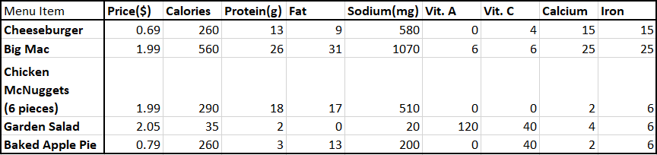

How many of each item should you purchase daily to minimize your cost while satisfying your nutritional needs? What is the daily cost of the optimal plan?

1. Mercotic is a leader in slip-ring industry. A $750,000 order has just been received. Unfortunately, Mercotic does not have enough wiring and harnessing capacity to fill the order by its due date. However, the company can subcontract any portion of this order to one of its competitors. Mercotic wants to determine the number of slip rings to make and number to buy to fill the customer order at the least possible cost. The wiring and harnessing capacities are 11,000 and 4,500 hours, respectively. All the necessary information is given in the table below.

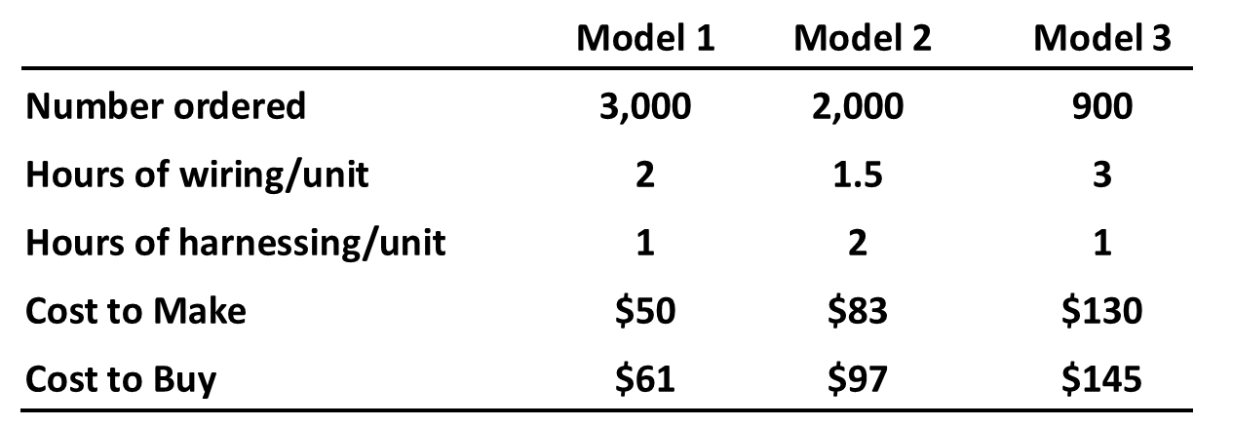

1. How much of each model should Mercotic buy and make to minimize costs?
2. Suppose now that Mary, Mercotic’s CEO would like to make sure that the firm produces at least as many Model 2s as Model 3s. She believes that this will decrease costs. Do you agree with this claim?
3. Mary consults industrial and manufacturing engineers, and they suggest that with a new process, each model can be produced using half of their current harnessing requirements. If this new process costs $10,000, should Mercotic use it? (Assume that Marc doesn’t require at least as many Model 2s and Model 3s.)
4. Mary suspects that only the relative costs of making and buying rather than the exact costs matter in the optimal solution. Specifically, she thinks that if the costs of making and buying increases by the same percentage, the optimal plan stays the same. Is she correct?
5. A paint manufacturer, PCBCo, must determine how much paint should be produced in the next four quarters. The firm estimates the demand for the next four months to be 40, 60, 75, and 25 in thousands of lbs. The firm must fully satisfy the demand in each month, i.e., no backlogging, In the beginning of period 1, PCBCo has an inventory of 10,000 lbs. The firm
6. has a production capacity of 40,000 lbs. each quarter with a per unit cost of $400 per thousand lbs using regular labor,
7. may have workers work overtime where the per unit cost increases to $450 per thousand lbs.,
8. incurs a holding cost of $20 per thousand lbs. at the end of a period.

How many lbs. of paint should PCBCo produce to satisfy demand while minimizing total production and inventory costs? (Hint: The inventory cost is based on the amount stored at the end of the period!)

1. *Cargo Loading* (Baker and Powell, 2013)*.* You are in charge of loading cargo ships for International Cargo Company (ICC) at a major East Coast port. You have been asked to prepare a loading plan for an ICC freighter bound for Africa. An agricultural commodities dealer would like to transport the following products aboard this ship:

| **Commodity** | **Tons Available** | **Volume per Ton (cu.ft.)** | **Profit per Ton ($)** |
| --- | --- | --- | --- |
| 1 | 4,000 | 40 | 70 |
| 2 | 3,000 | 25 | 50 |
| 3 | 2,000 | 60 | 60 |
| 4 | 1,000 | 50 | 80 |

You can elect to load any or all of the available commodities. However, the ship has three cargo holds with the following capacity restrictions:

| **Cargo Hold** | **Weight Capacity (tons)** | **Volume Capacity (cu.ft.)** |
| --- | --- | --- |
| Forward | 3,000 | 100,000 |
| Center | 5,000 | 150,000 |
| Rear | 2,000 | 120,000 |

More than one type of commodity can be placed in the same cargo hold. However, because of balance considerations, the weight in the forward cargo hold must be within 10 percent of the weight in the rear cargo hold, and the center cargo hold must be between 40 percent and 60 percent of the total weight on board. Solve this problem using Excel Solver.

1. *Coordinating Advertising and Production* (Baker and Powell, 2013). The Hawley Lighting Company manufactures four families of household lighting at its factory. The product families are table lamps, floor lamps, ceiling fixtures, and pendant lamps. The following table shows the average material costs for each of the products:

|  |  |  |  |  |
| --- | --- | --- | --- | --- |
| **Product** | **Table** | **Floor** | **Ceiling** | **Pendant** |
| **Material cost** | $66 | $85 | $50 | $80 |

Each product is made in one of two production processes by purchasing components, assembling and testing the product, and, finally, packaging it for shipping. Table lamps and floor lamps go through the assembly and finishing process in Department 1, while ceiling fixtures and chandeliers go through the process in Department 2. Variable production costs and capacities (measured in units of product) are shown in the following table. Note that there are regular and overtime possibilities for each department.

|  |  |  |  |  |
| --- | --- | --- | --- | --- |
|  | **Regular Time** | |  | **Overtime** |
| **Process** | Unit Cost | Capacity | Unit Cost | Capacity |
| **Department 1** | 16 | 100000 | 18 | 25000 |
| **Department 2** | 12 | 190000 | 15 | 24000 |

|  |  |  |  |  |
| --- | --- | --- | --- | --- |
| **Product** | **Table** | **Floor** | **Ceiling** | **Pendant** |
| **Selling Price** | 120 | 150 | 100 | 160 |
| **Potential sales (000)** | 60 | 20 | 100 | 35 |
| **Advertising Effect** | 12% | 10% | 8% | 15% |

Average selling prices for the four products are known, and estimates have been made of the market demand for each product at these prices. These figures are shown in the following table:

Sales levels can also be affected by advertising expenditures. Starting with the demand levels in the table, an increase of up to $10,000 in advertising raises the demand by the percent shown in the last row. An expenditure of less than $10,000 in advertising will lead to a proportional effect on demand. For example, an increase in advertising of $5,000 for table lamps would raise demand by 6 percent, or 3,600 units. However, there is a budget limit of $18,000 on the total amount to be spent on advertising among all four products.

a. What is an optimal output plan for the company?

1. For each department, what is the marginal value of additional overtime capacity?
2. What is the marginal value of additional advertising dollars?
3. What is the marginal value of additional sales for each product?
4. Williams apparel company produces two competing suits for women, the Executive and the Creativista. The markets for these suits are two different groups of customers. The valuation of these two suits by the two groups are given below:

|  |  |  |
| --- | --- | --- |
| Customers' values | |  |
|  | Group 1 | Group 2 |
| Value of the Executive | $1000 | $1200 |
| Value of the Creativista | $800 | $1500 |

Due to the high price of the suits, each customer usually buys only one suit. Customers’ choice is dependent on their net utility which is calculated as the value of a particular suit to a customer minus its price. Williams company would like to set the prices of the Executive and the Creativista suits such that all group 1 customers purchase the Executive and all group 2 customers purchase the Creativista. How much should the Williams company charge for each suit to maximize revenue? (The size of groups 1 and 2 are 1000 and 1500 customers, respectively. Suppose that if the net utilities of group 1 for the Executive and the Creativista are the same, group 1 will purchase the Executive. A similar condition applies to group 2.)

1. Unwind Wine company produces two types of blended wines, Ocean View and Lake Life by mixing two wines. Ocean View must contain at least 75% of type 1 wine and Lake Life must contain at least 45% of type 1 wine. Ocean View sells for $1 per ounce and Lake Life sells for $7 per ounce. The firm uses two types of mixing processes. The first process uses 8 ounces of raw material in one hour and 3 hours of labor and it yields 4 ounces of each type of wine. The second process uses 6 ounces of raw material, 2 hours of labor, and yields 5 ounces of type 1 and 2 ounces of type 2 wine. Unwind Wine company has 6000 ounces of raw material and 2000 hours of labor available. Write the linear mathematical model that maximizes Unwind Wine Company’s revenue.
2. Cleveland Bank has 30 bankers who work 5 days a week. The number of bankers needed each day depends on the day and is as follows: Monday, 18; Tuesday, 24; Wednesday, 25; Thursday, 16; Friday, 21; Saturday, 28; and Sunday, 18.
   1. Solve the model that minimizes the numbers of bankers whose days off are not consecutive using Excel solver.
   2. Solve model that minimizes the numbers of bankers whose days off are consecutive using Excel solver.

**References**

Baker, K.R., Powell, S.G., 2013. Management Science, The Art of Modeling with Spreadsheets, Management Science - The Art of Modeling with Spreadsheet. https://doi.org/10.1371/journal.pone.0147247